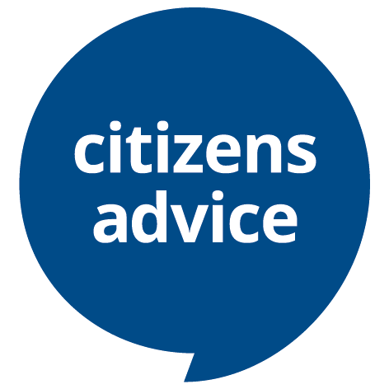
Volunteer diversity monitoring information
Background
Citizens Advice values diversity, promotes equality, and challenges discrimination. We welcome and encourage volunteer applications from people of all backgrounds, age, disability, gender, gender identity, marriage and civil partnership, pregnancy and maternity, race, religion or belief, sexual orientation.
Monitoring recruitment and selection procedures is one way that helps us to ensure that there is no discrimination in our recruitment process. To do this we need to know about the diversity profile of people who apply for volunteer roles at Citizens Advice x.

Data protection overview

If you are happy to provide it, we will use this information for the sole purpose of allowing us to monitor equality of opportunity and treatment as necessary to maintain or promote equality within Citizens Advice ****.

The information you give us will be kept securely, won't be shared outside the service and is confidential.

It will not be seen by anyone responsible for making recruitment decisions or have any impact on you directly.

If you are successful in your application and we require this information for other purposes, you will be asked to provide it separately - i.e. this form will not be used for other purposes.

If you would prefer not to answer any of the questions we ask, please leave them blank. If you would like us stop using the information you provide, please contact us.
Note on accessibility: If you are using keyboard only and need to put a cross in the relevant box, you should be able to arrow across, and type in the box. If this is not possible put a cross next to the relevant box. If you need this form in another format please contact your local Citizens Advice ****.

Diversity Monitoring Form
Applicant ref. number
(local Citizens Advice use only):
Which volunteer role are you applying for?

Age
Which age bracket do you fit into? Put a cross in the relevant box.

Under 25
25 - 34
35 - 44
45 - 54
55 - 64
65 and over
Prefer not to say

Gender
What term best describes your gender? Put a cross in the relevant box or write in a preferred term.
Female
Male
I prefer to use another term

Please write in……………………………………...
Prefer not to say

Sexual orientation
What is your sexual orientation? Put a cross in the relevant box or write in a preferred term.
Heterosexual/Straight
Gay Man
Gay Woman/Lesbian
Bisexual
I prefer to use another term

Please write in……………………………………….
Prefer not to say

Ethnic origin
How would you describe yourself? Choose one section (A to E) and put a cross in the relevant box within it.

A. White | English/Welsh/Scottish/Northern Irish/British
 | Irish
 | Gypsy or Irish Traveller
Any other White background

Please write in……………………………………….
B. Mixed/multiple ethnic groups | White & Black Caribbean
 | White & Black African
 | White & Asian
Any other Mixed/multiple ethnic background

Please write in……………………………………….
C. Asian/Asian British | Indian
 | Pakistani
 | Bangladeshi
 | Chinese
Any other Asian Background

Please write in……………………………………….
D. Black/African/ Caribbean/Black British | African
 | Caribbean
Other Black/African/Caribbean background

Please write in……………………………………….
E. Other ethnic group | Arab
Any other ethnic group

Please write in……………………………………….
Prefer not to say

Disability
A disabled person is defined under the Equality Act 2010 as someone with a ‘physical or mental impairment which has a substantial and long term adverse effect on that person’s ability to carry out normal day-to-day activities.’

Do you consider yourself to be disabled under the Equality Act 2010?

Yes
No
Prefer not to say

The information on this form is for monitoring purposes only. If you require any reasonable adjustments to be made in the recruitment process or at work subsequently if appointed, please make sure you tell us separately from this form. We follow the social model of disability which believes that it is the barriers created by society which disable people. We will use reasonable adjustments wherever possible to remove those barriers.

Gender Identity
Do you identify as *Trans?

Yes
No
Prefer not to say

*Trans is an umbrella term to describe people whose identity is not the same as the sex they were assigned at birth. People under the trans umbrella may describe themselves using one or more of a wide variety of terms – including transgender.

Religion or belief
Which group below do you most identify with? Put a cross in the relevant box.
No religion
Christian (including all denominations)
Buddhist
Hindu
Jewish
Muslim
Sikh
Any other religion or belief

Please write in……………………………………….
Prefer not to say

How did you hear about this opportunity?

Please include details below:

