2

Trustee Pack

September 2023
www.citizensadvicetelfordandthewrekin.org.uk
@TelfordCAB www.facebook.com/telfordcab
Contents
Introduction - Chair, Trustee Board Page 2
Our Values Page 3
Three things you should know about Citizens Advice Page 3
About Citizens Advice Telford & the Wrekin (CAT&W) Page 3
The Trustee Role Page 4
What’s in it for you? Page 5
Trustee Profile Page 5
Time Commitment Page 5
How to Apply Page 6
Appointment Process Page 6
Application Form See separate enclosure
Diversity Monitoring Form See separate enclosure

Introduction
Chair, Trustee Board
Thank you for your interest in becoming a Trustee of Citizens Advice Telford & The Wrekin (CAT&W). This pack should give you everything you need to know and how to apply for this role.
Every year thousands of people living in Telford come to us for help. We are here for everyone that has problems across a huge range of issues.
In this pack you will learn about the numbers of people that we helped, the financial value to the community, and not least the contribution of our Trustees and volunteers.
From these many client contacts, we are also able to identify trends which helps us to understand better our clients’ needs and how to influence policy change at a local and national level.
We hope you will want to join us in supporting this vital work.

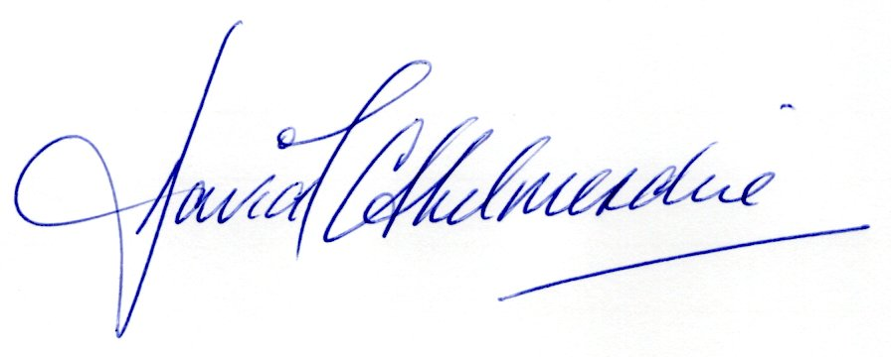
David J C Shelmerdine
Chair

Want to chat about this role?
Do drop us an email (volunterrecruitment@telfordcab.co.uk) with your contact details and either myself or our Chief Executive Louise Cross will be in touch.

Our Values
We’re inventive: We’re not afraid of trying new things and learning by getting things wrong. We question every idea to make it better and we make change when things aren’t working.
We’re generous: We work together, sharing knowledge and experience to solve problems. We tell it like it is and respect everyone.
We’re responsible: We do what we say we’ll do and keep our promises. We remember that we are a charity and use our resources effectively.

Three things you should know about Citizens Advice
- Citizens Advice is local and national: We are one of some 340 independent local Citizens Advice services across England and Wales and offer direct support to people in and around Telford, Shropshire. We are a member of the national Citizens Advice network.
- We’re here for everyone: Our advice helps people solve problems and our advocacy helps fix problems in society. Whatever the problem, we won’t turn people away.
- We’re listened to and we make a difference: Our trusted brand and the quality of our research mean we make a real impact on behalf of the people who rely on us.

About Citizens Advice Telford and the Wrekin
CAT&W was formed in 1999 from the merger of three smaller bureaux. We are an independent charity and limited company, managed by a Board of Trustees.
We have 33 members of staff, equating to 17 FTE posts. As a charity we rely on our volunteers and trustees, of which we have 16 volunteers and 9 Trustees. We are based in our own premises in Wellington, Telford.
We are members of Citizens Advice, the National Association of Citizens Advice Bureaux. We hold the Quality Mark for Generalist Advice and are approved by the Financial Conduct Authority (FCA).
We help people to resolve their legal, financial, and other problems by providing information and advice and by influencing policymakers. We also provide a range of specialist casework and targeted services including debt and energy issues.
The service is free, confidential, impartial, and independent. It is open to everyone. Almost half of the population will use a Citizens Advice service at some time, and we are the largest provider of debt and money advice in the Borough.
In 2022/2023 we helped 11,649 clients to resolve 35,707 issues including over £237,000 of debt written off. We also secured £4,913,075 of additional income for clients.
CAT&W offers advice at our main office and through a number of outreach locations which can be seen on our website. Advice is offered by face-to-face appointments and by telephone through our national Adviceline and our local line for Telford & Wrekin clients.
Generalist advice at the main office is provided by a team of staff and volunteer advisers who have all undertaken extensive training for the role. The demand for advice is consistently high and we are always looking for more volunteers to help increase our capacity and the quality of advice that we can offer to our clients.
We have a mixed funding base with a grant from Telford and Wrekin Council which is very supportive. In addition to our general advice service, we run a range of specific projects:
- Money Advice – debts advice and casework
- Help to Claim – to help clients claim Universal Credit
- Energy Advice – for individuals and groups
- Baby Steps – support for expectant or new parents
- HMRC Project – to help clients understand benefit entitlement, complying with their tax obligations, or accessing other HMRC services and products, including those who are digitally excluded.
- The Net – crisis support in partnership with Stay & Mind in Telford & Wrekin
- Enable – supported employment advice.
- Food Bank – providing food bank referrals to clients or offering emergency food parcels.
- Strengthening Families – dedicated advice for families with children with multiple needs
We enjoy strong links and play an active role as part of the network of other agencies working in Telford both statutory and in the voluntary and community sector, ensuring that our service is responsive and relevant to meet local needs.
We strive to continually improve our service by seeking feedback from our clients, partners, and funders and by regular monitoring of quality and levels of service.
We welcome diversity and are striving to develop a team of Trustees, staff and volunteers that reflect the community that we serve.

The Trustee Role
As a member of the Trustee Board you will help to ensure CAT&W is working within its charitable objects and is financially sustainable, whilst meeting the needs of the community. This work requires governance, leadership, and strategy skills.
The Board seeks to recruit Trustees with specialist skills. At this time, the Board are seeking to recruit a volunteer treasurer (see separate recruitment pack) and a Trustee with current people management/HR experience, although all applications will be considered.
What will you do?
As a Trustee you will
- complete an induction for your role and training
- maintain mandatory training (online)
- read papers for Board meetings and attend approximately five Board meetings per year and if required participate in decisions in between Board meetings by email.
- maintain awareness of how the charity operates and its external environment
- work, if interested, on specific projects or sub-Committees with other Trustees or staff within CAT&W to further our strategic objectives
- take an active role in discussions and decisions during Board meetings and work with other Trustees to:
- set policy and strategic direction; monitor and evaluate the strategic performance of CAT&W
- monitor the financial position of CAT&W ensuring that it operates within parameters and policies set by the Board whilst having a sustainable financial plan
- ensure that the charity represents the views of all sections of the community and monitor how well the service meets the needs of the local community and those who need our help the most.
- discuss and manage strategic risks and mitigation
- review its own work as a Board and how effectively it operates including deciding actions for improvement
What’s in it for you?
As a Trustee you will
- be making a positive impact for people in Telford by ensuring CAT&W is sustainable and meeting the needs of the community
- meet people and build relationships with your fellow Trustees, staff and volunteers
- build on your governance, leadership, and strategy skills

Trustee Profile
All Trustees need:
- to understand and accept the responsibilities and liabilities of the role
- be non-judgmental and respect views, values and cultures that are different to your own
- have good listening, verbal and written communication skills
- be able to exercise good independent judgment
- have good numeracy skills to understand accounts (with the support of the Treasurer)
- be willing to learn about and follow Citizens Advice’s aims, principles and policies, including confidentiality and data protection
- be willing to undertake training in your role
As mentioned above the Board is currently seeking to recruit Trustees with expertise in the following areas:
- charity finance
- people management/human resources

Valuing inclusion
Our volunteers come from a range of backgrounds and we particularly welcome applications from disabled people, people with physical or mental health conditions, LGBT+ and non-binary people, and people from Black Asian Minority Ethnic (BAME) communities.

Time Commitment
The CAT&W Trustee Board meets a minimum of five times a year in the early evening (usually 1700 hrs) and the meetings are online or hybrid. However, where possible, Board meetings are scheduled at times to suit members.
You may be invited to join one of two sub-Committees (Finance and Staffing). These groups meet as and when required and usually during the day. Again, meetings are arranged to suit, where possible, members diaries. The meetings are usually held online.
There may be other meetings or actions needed in addition to the five full Board meetings e.g. one off decisions by email, one off single agenda meetings, planning days, briefing meetings with Telford and Wrekin Councillors or Members of Parliament, for specific projects.
We can be flexible about the time you can give to CAT&W and how often you are available.

How to Apply

Trustee Application Form or CV with Covering Letter
To make sure the application process is as accessible as possible we have several ways for you to apply:
Please complete the Application Form and return it by email to:
volunterrecruitment@telfordcab.co.uk
or
Complete the online application form by visiting this link: https://forms.office.com/e/6dE2mKEjG6
or
Send your CV to volunteerrecruitment@telfordcab.co.uk along with a covering note explaining why you would like to join the Trustee Board.

Diversity Monitoring
CAT&W encourages and welcomes applications from suitably skilled candidates from all backgrounds. Please see the enclosed Diversity Monitoring Form for more details. The completed form should be returned by email to volunteerrecruitment@telfordcab.co.uk

Appointment Process
On receipt of your application, you will be invited to an informal meeting with the Chair and/or CEO to discuss the Trustee role and what skills and experience you can offer to our work. This may be an online meeting.
After the meeting, if both parties agree to proceed you will be invited to join the next Board meeting and be introduced to the other Trustees.
Following the Board meeting you will be asked if you wish to continue with your application. If so, a proposal will be put to the Board to co-opt you as a member.
Formal appointment as a Trustee is a matter for the Annual General Meeting which is held annually in the Autumn.
References
All applicants are asked to provide the names and contact details of two referees. See the Application Form for more details.
Criminal Convictions
Anyone who applies will be asked to disclose details of unspent convictions. See the Application Form for more details.

