Help to Claim adviser
Job pack

Thanks for your interest in working at Citizens Advice Telford and The Wrekin This job pack should give you everything you need to know to apply for this role and what it means to work at Citizens Advice.

In this pack you’ll find:
- Our values
- 3 things you should know about us
- Overview of Citizens Advice and Citizens Advice Telford and The Wrekin
- The role profile and personal specification
- What we give our staff

Want to chat about this role?
If you want to chat about the role further, email us on recruitment@telfordcab.co.uk and leave your details and we will contact you

Our values
We’re inventive. We’re not afraid of trying new things and learn by getting things wrong. We question every idea to make it better and we change when things aren’t working.
We’re generous. We work together, sharing knowledge and experience to solve problems. We tell it like it is and respect everyone.
We’re responsible. We do what we say we’ll do and keep our promises. We remember that we work for a charity and use our resources effectively.
3 things you should know about us

1. We’re local and we’re national. We have 6 national offices and offer direct support to people in around 300 independent local Citizens Advice services across England and Wales.

2. We’re here for everyone. Our advice helps people solve problems and our advocacy helps fix problems in society. Whatever the problem, we won’t turn people away.

3. We’re listened to - and we make a difference. Our trusted brand and the quality of our research mean we make a real impact on behalf of the people who rely on us.

How Citizens Advice Telford and The Wrekin works

Citizens Advice Telford and The Wrekin (CATW) provides information and advice for residents of Telford and The Wrekin. We currently have a team of 32 employees and our local advice services are supported by a team of volunteer advisers. Our core services focus on providing free, independent, and impartial advice on benefits, debt, housing, employment, relationship, and immigration issues, together with support for clients in crisis. This includes clients most affected most by the current cost-of-living crisis who may be in food or fuel poverty, or at risk of homelessness.

We currently deliver a range of projects that support clients across these advice areas including Help To Claim (Universal Credit new claims) on behalf of the Department for Work and Pensions and Money Advice Service Debt Advice. We have recently moved to a new delivery site in central Telford where we undertake face-to-face, telephone and email advice. We also provide face-to-face information and advice across a network of 18 community and outreach locations, and at local events/employers.

We currently employ 9 home-based Help To Claim Telephone and Webchat Advisers who are supported by a dedicated Quality of Advice Assessment Officer and Line Manager.

More information about our services is at www.citizensadvicetelfordandthewrekin.org.uk

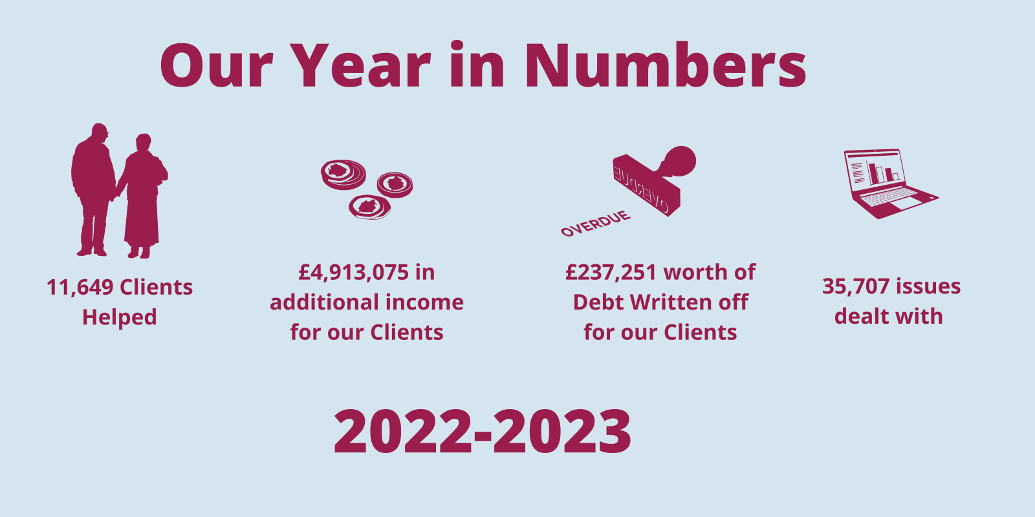

Overview of Citizens Advice

The Citizens Advice service is made up of Citizens Advice - the national charity - and a network of around 300 local Citizens Advice members.  This role sits our network of independent charities, delivering services from  - over 600 local Citizens Advice outlets  - over 1,800 community centres, GPs’ surgeries and prisons  They do this with:  - 6,500 local staff  - over 23,000 trained volunteers  Our reach means 99% of people in England and Wales can access a local Citizens Advice within a 30 minute drive of where they live. | 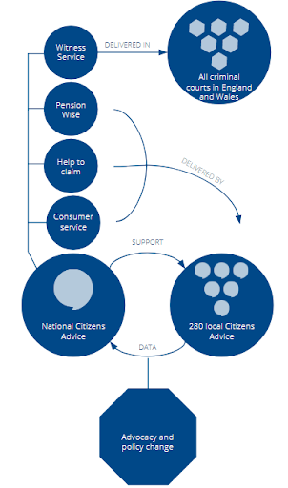

The role
Citizens Advice delivers “Help to Claim” which offers end-to-end support to help people make a new Universal Credit claim and be ready for when their first payment arrives.
We are looking for an adviser with good IT skills to support clients to make and complete their new Universal Credit claim, as well as a commitment to the aims and principles of the Citizens Advice Service.

You’ll have the ability to interview clients using sensitive listening and questioning skills to get to the root of the issues and empower clients, whilst maintaining structure and control of meetings.

Role profile
Advice giving

Act for the client where necessary using appropriate communication skills and channels.

Refer internally or to other specialist agencies as
appropriate.

Ensure that all work meets quality standards and the requirements of the funder

Ensure that work reflects and supports the Citizens Advice service's equality and diversity strategy. Interview clients using sensitive listening and questioning skills in order to allow clients to explain their problem(s) and empower them to set their own priorities

Supporting clients to use IT to make their new Universal Credit claim

Use Citizens Advice resources to find, interpret and communicate the relevant information to clients

Complete benefits checks when appropriate

Research and explore options and implications so that clients can make informed decisions.

Maintain detailed case records for the purpose of continuity of casework, information retrieval, statistical monitoring and report preparation.

Work in a variety of settings including community outreach, Jobcentres and local authority offices as required

Complete the required training to comply with quality assurance processes

Research and campaigns

Support our research and campaigns work through various channels including case studies, data collection and client consent

Professional development

Keep up to date with legislation, policies and procedures and undertake appropriate training

Read relevant publications

Attend relevant internal and external meetings as agreed with the line manager

Prepare for and attend supervision sessions/team meetings/staff meetings as appropriate

Administration

Use of telephony and IT equipment for multichannel delivery of advice services

Use of IT software for statistical recording of information relating to research and campaigns and funding requirements, record keeping and document production. Ensure GDPR compliant training is completed on an annual basis

Ensure that all work conforms to your organisation’s systems and procedures

Other duties and responsibilities

Carry out any other tasks that may be within the scope of the post to ensure the effective delivery and development of the service

Demonstrate commitment to the aims and policies of Citizens Advice

Abide by health and safety guidelines and share responsibility for own safety and that of colleagues

Person specification
Essential
Ability to use sensitive listening and questioning skills to get to the root of the issues and empower clients, whilst maintaining structure and control of meetings with them

Ability to give and receive feedback objectively and sensitively and a willingness to challenge constructively

Ability to use telephony and IT systems to deliver services across multiple channels for example webchat and telephone

Ability to use IT systems and packages, and resources in the provision of advice, record keeping and document production

Good IT knowledge with an ability to support clients with their online claim application

Ability and willingness to work as part of a team

A commitment to continuous professional development, including a willingness to develop knowledge and skills in advice topics

Ability to work in outreach settings with an understanding of information assurance and safety in those settings

Ability to develop and maintain positive working relationships with external stakeholders

Ability to commit to and work with the aims, principles and policies of the Citizens Advice service

A good up to date understanding of equality and diversity and its application to the provision of advice

Ability to monitor and maintain standards for advice provision and quality assurance

Desirable

Knowledge of the benefits systems including Universal Credit

Ability to carry out accurate benefit check calculations

Basic knowledge of multiple enquiry areas to aid with identifying emergencies and making referrals where appropriate

In accordance with Citizens Advice national policy, the successful candidate will be screened by the DBS. However, a criminal record will not necessarily be a bar to your being able to take up the job.

What we give our staff
Generous holiday entitlement:
25 days (full-time equivalent, excluding bank holidays)

Long-service holiday
Increase after 1 year of service by 1 day per year up to a maximum of 5 extra days.

Flexible working

Company pension scheme

Lifeworks Employee Assistance Programme wellbeing support

Ongoing training and development opportunities

