Dear Applicant

Re: Recruitment – Help To Claim Telephone and Webchat Adviser

Thank you for your interest in this position.

Please see attached application pack which has the following:

1. Job pack including role and person specification
2. Application form and monitoring form
3. Guidance notes including our Equality Statement

The closing date for receipt of applications is Monday 8th April at 5pm.
Candidates will be invited to interview on Microsoft Teams. Please let us know in your application if you need an alternative platform or a face-to-face interview

Copies of the Job Pack including the application form are on our website at
https://www.citizensadvicetelfordandthewrekin.org.uk/get-involved/work-with-us

Please email completed application forms to recruitment@telfordcab.co.uk

Please note that we do not provide feedback to candidates who are not selected for interview.

Yours sincerely

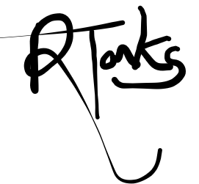

Rich Tonks
Advice Services and Quality Manager

For and on behalf of Citizens Advice Telford & The Wrekin

